**6.2 ON AND USING CLAUSE**

**SELECT EMP_ID,EMP_NAME,DEP_ID FROM EMPLOYEES JOIN DEP1 USING (DEP_ID);**

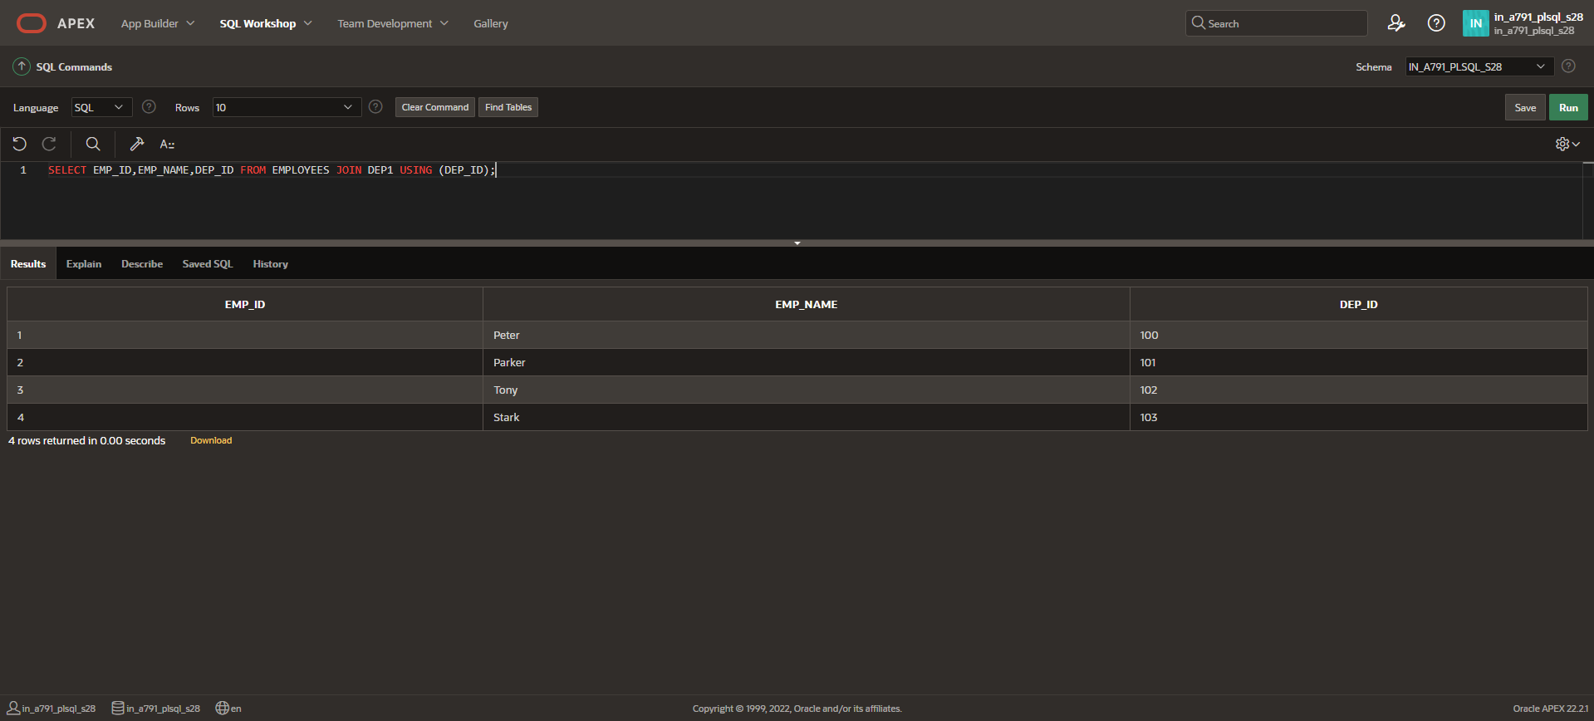

**SELECT EMP_ID,EMP_NAME FROM EMPLOYEES e JOIN DEP1 j ON (e.DEP_ID=j.DEP_ID);**

